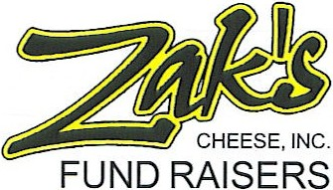
Dear Sponsor

Is your group looking for a quality fund raising program? Are you tired of selling over-priced junk? Would you like to make 40% profit with no money down and no hidden costs? Many schools and groups, such as yours, have found Zak’s Cheese to be a very popular and profitable fund raising program. It is one that the people in your community will look forward to year after year.

Zak’s Fund Raising has been doing fund raisers since 1983. We believe if you provide an excellent product at a reasonable price, people will look forward to your fund raising project instead of just thinking of it as a donation. Our staff is here to help you have the simplest and most successful fund raiser possible.

We will provide all the materials you need to have for your project including cheese samples, order forms, and prize brochures. We suggest having a cheese party to kick off your project. Each person will take orders for a week to ten days on the order form. At the end of the selling period, you simply tally the order on the form and call the order into our office on our toll-free number or you may fax your order. Zak’s will have your cheese to you in two to three weeks. Payment to Zak’s is due 30 days from the date of delivery, so you can deliver your orders and get your money collected before your invoice is due. We also have a prize incentive program, which we provide at no cost to your group.

Below is an example of the selling price and profit for each item sold, keep in mind these are examples only. Please call for current pricing and profit margins.

Selling price Your groups profit
String Cheese $9.00 $3.60
Summer Sausage 9.00 3.60
22 oz. Cheeses 11.00 4.40
Gift Boxes
A. Triple Treat 15.00 5.25
B. Family Favorites 25.00 8.75
Fudge with Nuts 7.50 3.00
Fudge Plain 7.50 3.00
Mints 5.50 2.20
Summer Stix 5.50 2.20
Peanuts 6.50 2.90
Peanut Brittle 7.50 3.00

If you have any questions, or if we can be of further assistance, please call us at 1-800-999-7637. We are looking forward to working with you and making this the best fund raiser you have done!

Sincerely

Suzanne Bryan
Zak’s Cheese

